Table of Contents

Assignment 2 2

Exercise 2 OLS 2

Exercise 4 Discrete Choice 2

Exercise 5 Marginal Effects 3

Assignment 3 4

Exercise 2 First Model 4

Exercise 3 Second Model 5

Exercise 4 : Marginal Effects 7

**Conditional Logit ME** 7

**Multinomial Logit ME** 8

Exercise 5 IIA 9

**Mixed Logit Unrestricted** 9

**Mixed Logit Restricted** 11

**IIA test** 13

Assignment 4 14

Exercise 1 Data 14

Exercise 2 & 3 Random and Fixed Effects 15

# Assignment 2

## Exercise 2 OLS

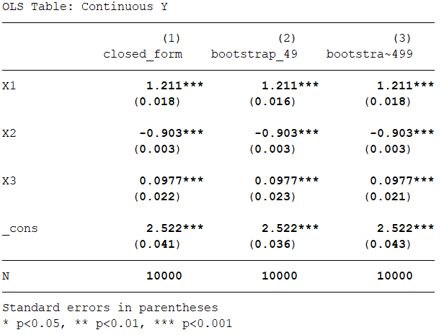

## Exercise 4 Discrete Choice

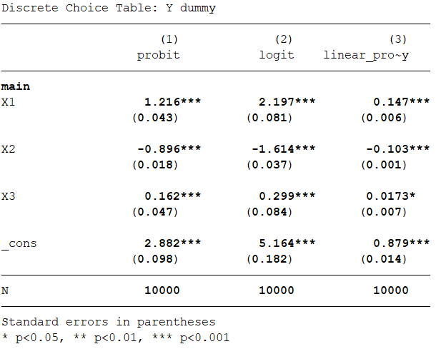

Exercise 5 Marginal Effects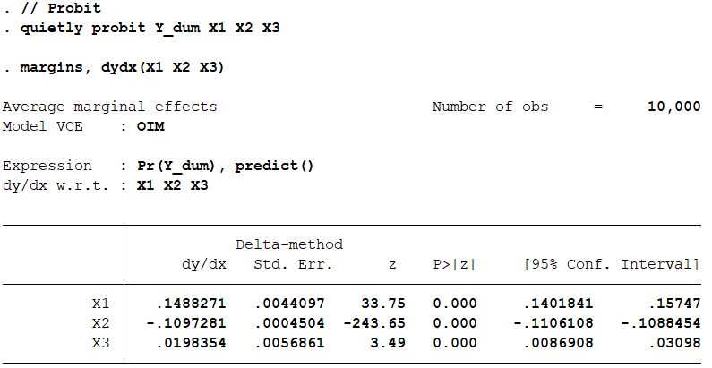

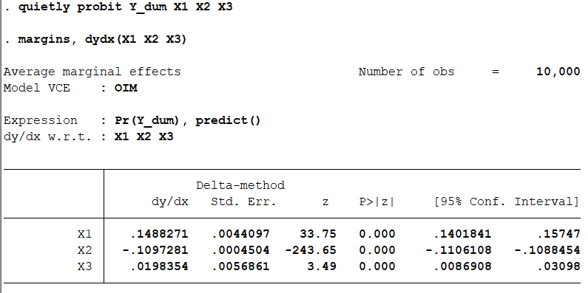

# Assignment 3

## Exercise 2 First Model

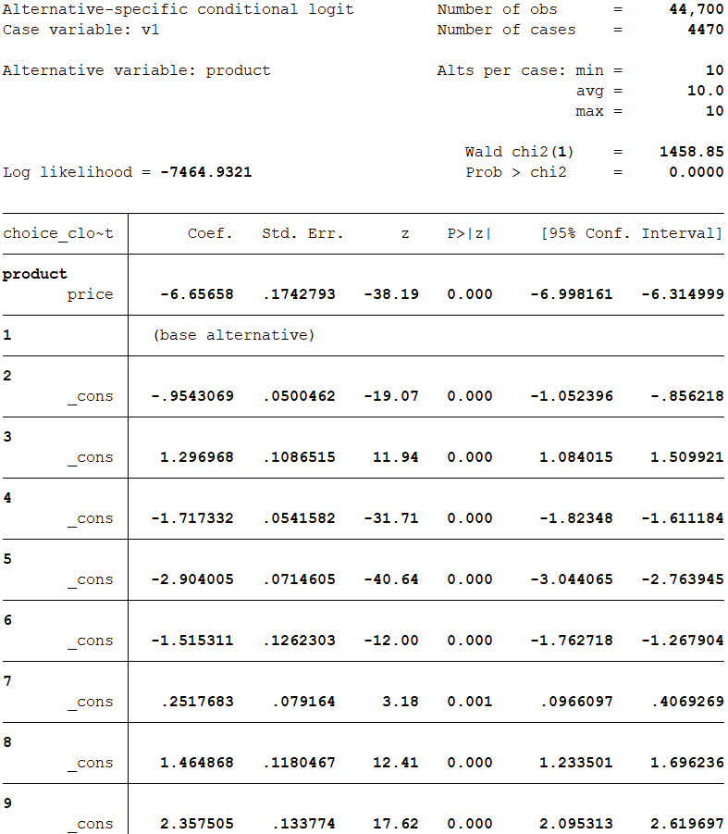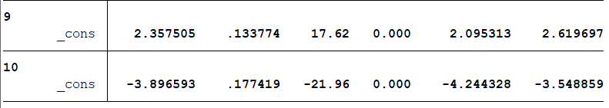

## Exercise 3 Second Model

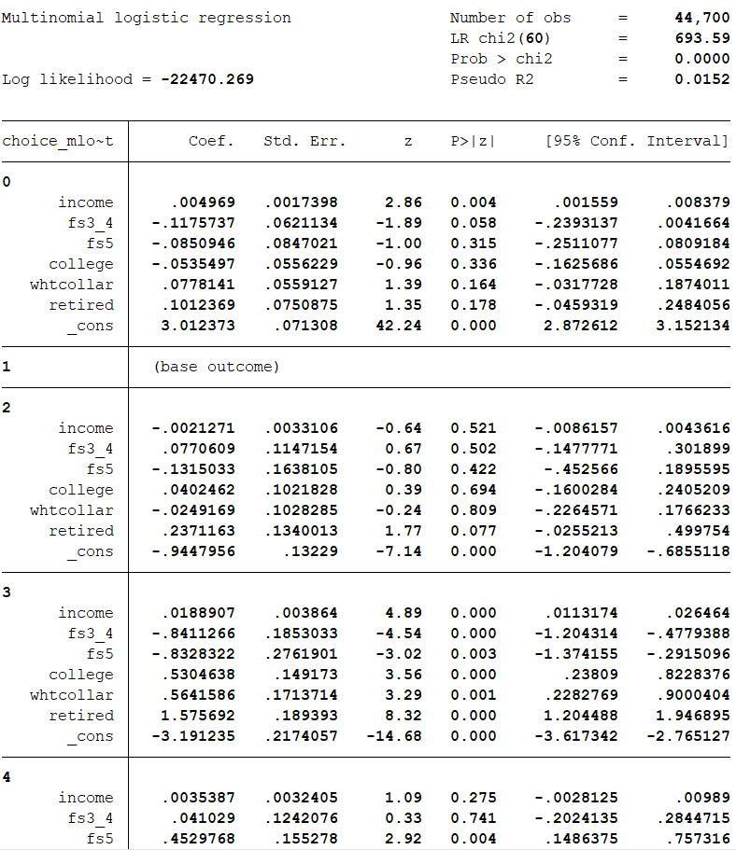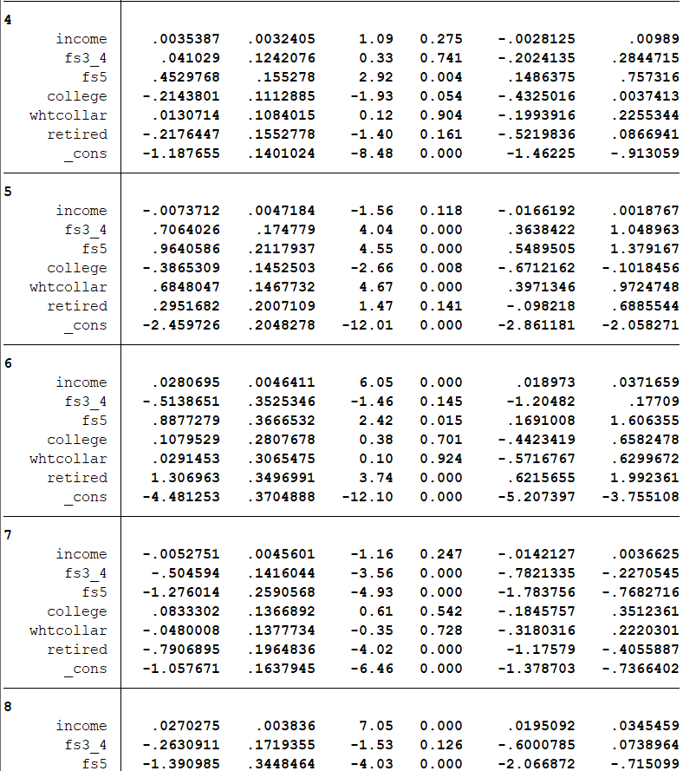

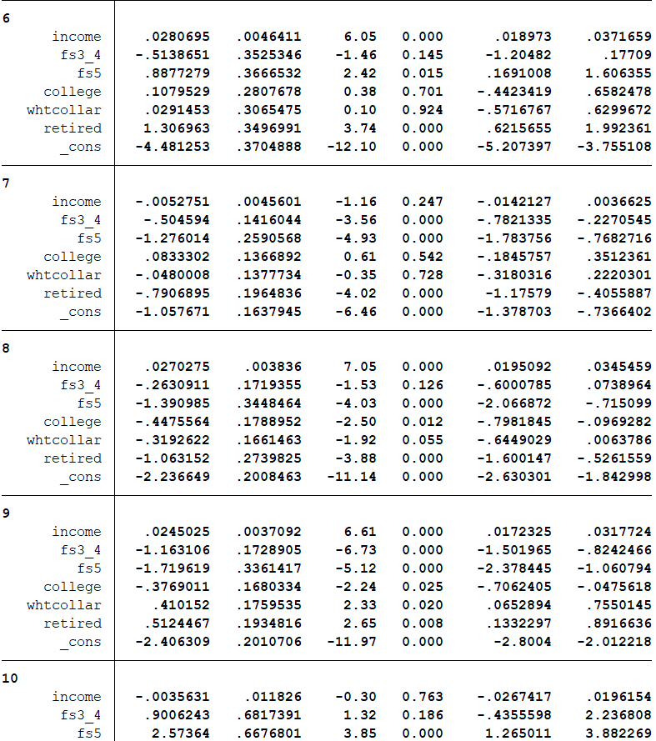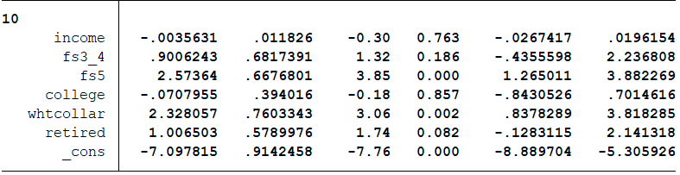

## Exercise 4 : Marginal Effects

The table from stat is too long so I collect the ME and put into the table here

### **Conditional Logit ME**

|  |  |  |  |  |  |  |  |  |  |  |
| --- | --- | --- | --- | --- | --- | --- | --- | --- | --- | --- |
|  | Prob_ product_1 | Prob_ product_2 | Prob_ product_3 | Prob_ product_4 | Prob_ product_5 | Prob_ product_6 | Prob_ product_7 | Prob_ product_8 | Prob_ product_9 | Prob_ product_10 |
| Product 1 Price Change | -1.62007 | 0.38092 | 0.156526 | 0.359811 | 0.202435 | 0.04471 | 0.194866 | 0.12222 | 0.14162 | 0.016959 |
| Product 2 Price Change | 0.38092 | -0.785545 | 0.051111 | 0.117491 | 0.066102 | 0.014599 | 0.063631 | 0.039909 | 0.046244 | 0.005538 |
| Product 3 Price Change | 0.156526 | 0.051111 | -0.352902 | 0.048279 | 0.027162 | 0.005999 | 0.026147 | 0.016399 | 0.019002 | 0.002276 |
| Product 4 Price Change | 0.359811 | 0.117491 | 0.048279 | -0.748524 | 0.062439 | 0.01379 | 0.060104 | 0.037698 | 0.043681 | 0.005231 |
| Product 5 Price Change | 0.202435 | 0.066102 | 0.027162 | 0.062439 | -0.44844 | 0.007759 | 0.033816 | 0.021209 | 0.024576 | 0.002943 |
| Product 6 Price Change | 0.04471 | 0.014599 | 0.005999 | 0.01379 | 0.007759 | -0.105088 | 0.007469 | 0.004684 | 0.005428 | 0.00065 |
| Product 7 Price Change | 0.194866 | 0.063631 | 0.026147 | 0.060104 | 0.033816 | 0.007469 | -0.432938 | 0.020416 | 0.023657 | 0.002833 |
| Product 8 Price Change | 0.12222 | 0.039909 | 0.016399 | 0.037698 | 0.021209 | 0.004684 | 0.020416 | -0.279151 | 0.014838 | 0.001777 |
| Product 9 Price Change | 0.14162 | 0.046244 | 0.019002 | 0.043681 | 0.024576 | 0.005428 | 0.023657 | 0.014838 | -0.321105 | 0.002059 |
| Product 10 Price Change | 0.016959 | 0.005538 | 0.002276 | 0.005231 | 0.002943 | 0.00065 | 0.002833 | 0.001777 | 0.002059 | -0.040265 |

### **Multinomial Logit ME**

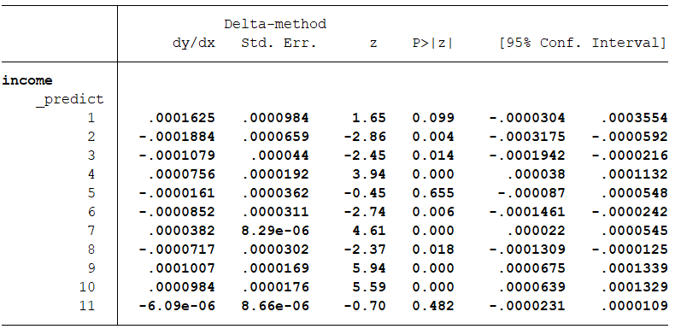

## Exercise 5 IIA

### **Mixed Logit Unrestricted**

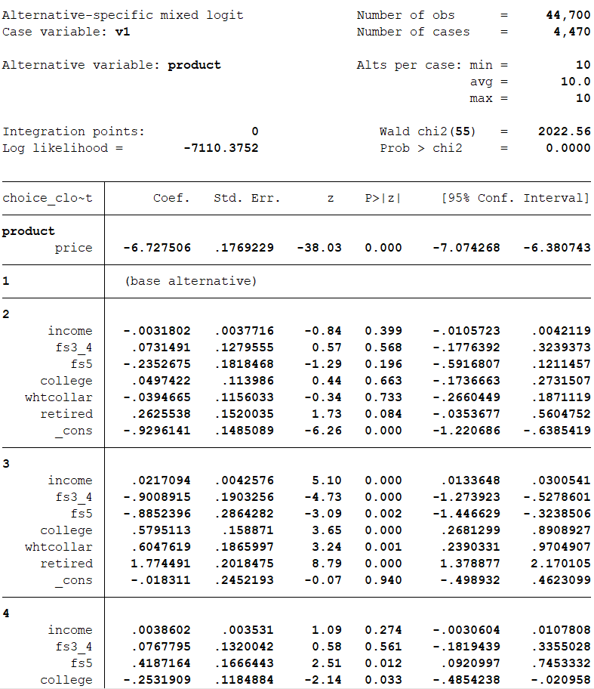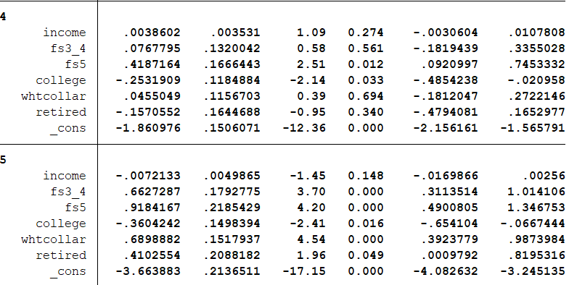

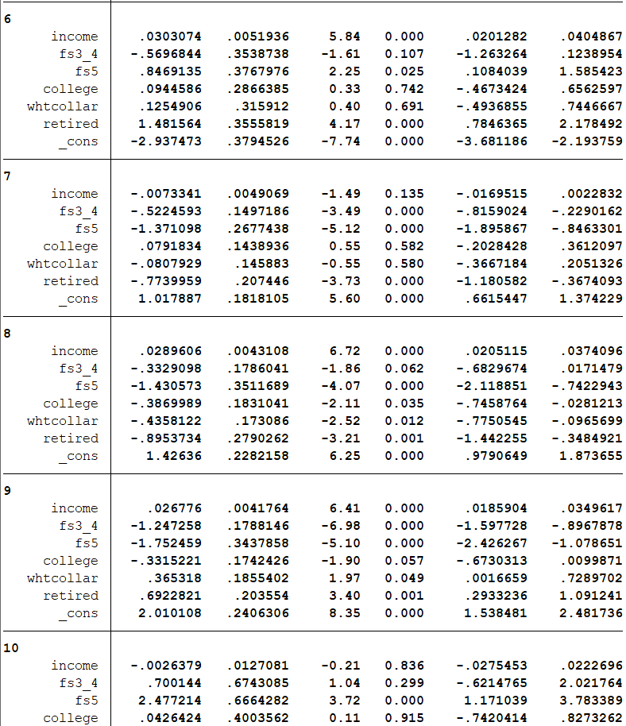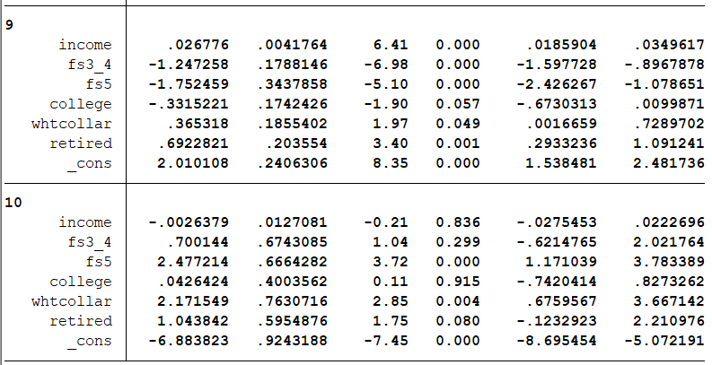

### **Mixed Logit Restricted**

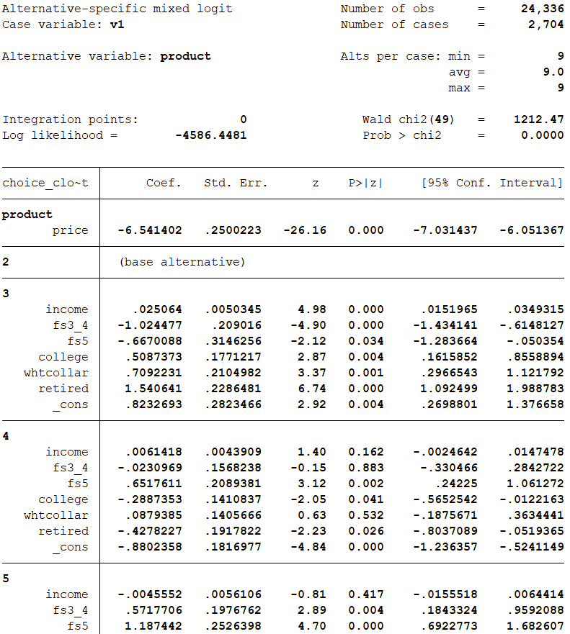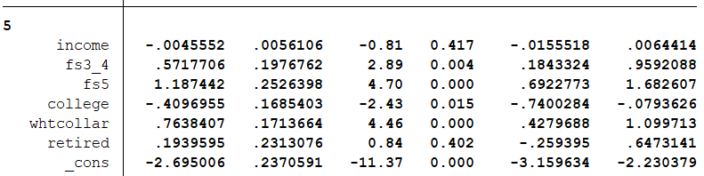

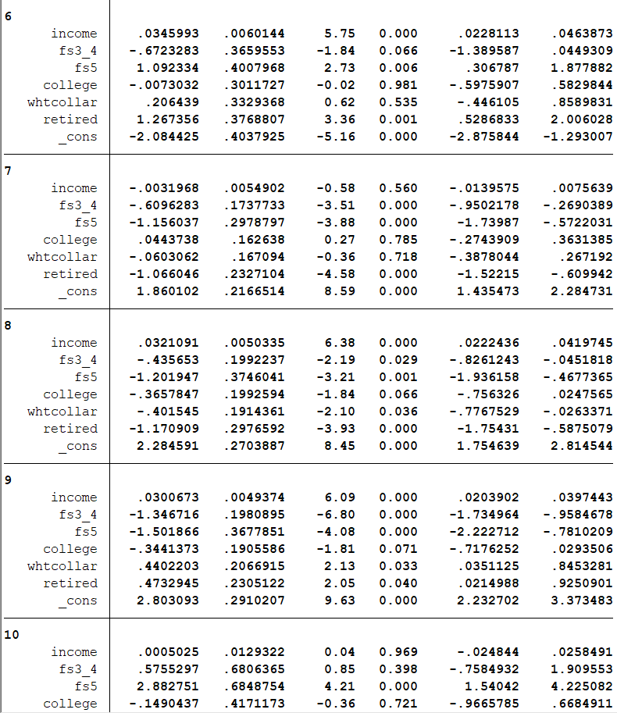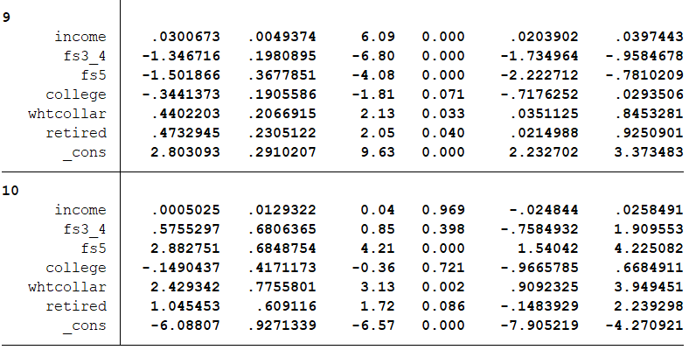

### **IIA test**

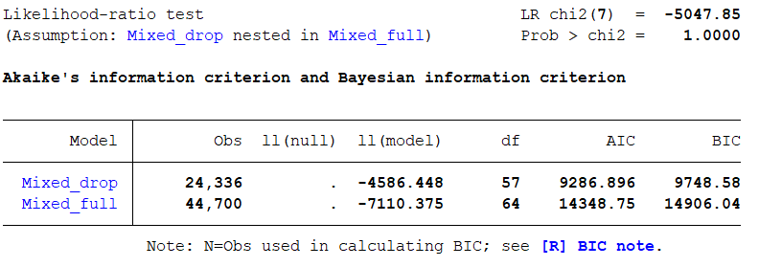

# Assignment 4

## Exercise 1 Data

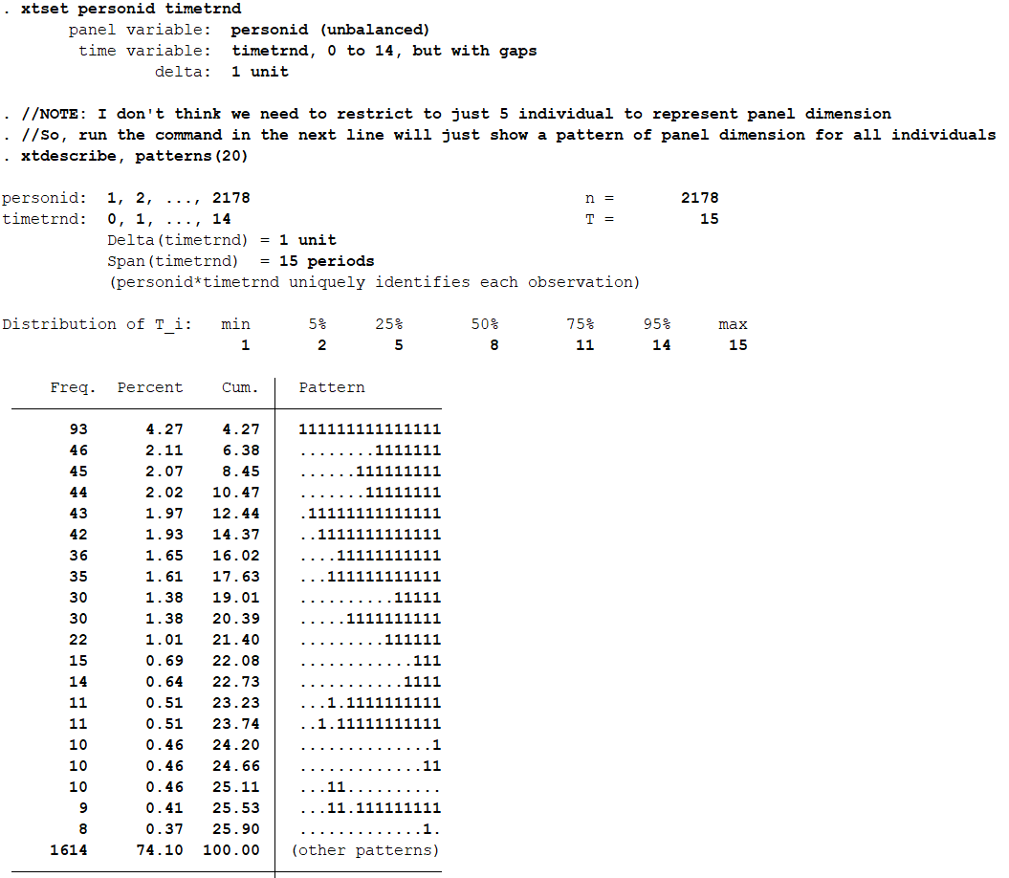

## Exercise 2 & 3 Random and Fixed Effects

